Database Design

Entity Relationship Diagram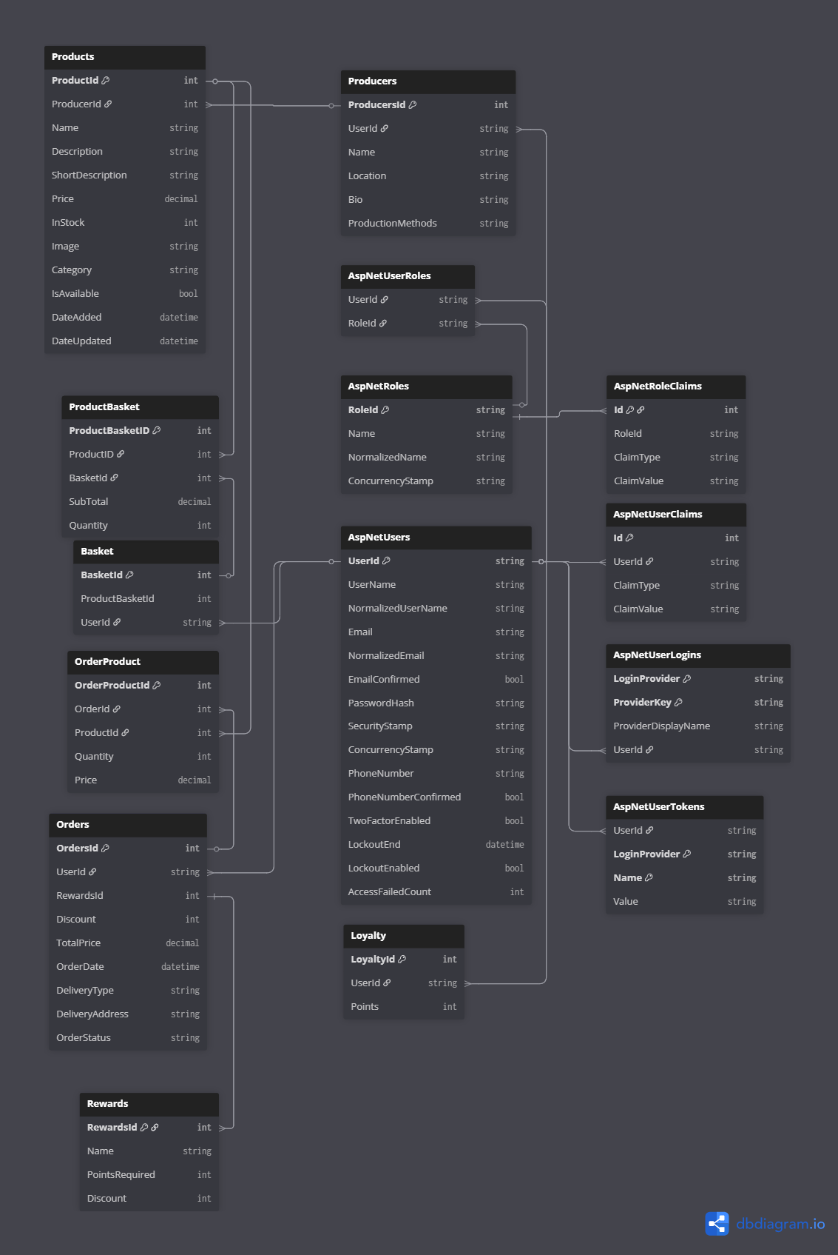

Data Dictionary

Products
Column | Data Type | Required | Nullable | Validation | Primary/Foreign
ProductId | int | Yes | No | Auto-generated unique number | Primary
ProducerId | int | Yes | No | Must match an existing producer ID | Foreign
Name | string | Yes | No | Cannot be empty
Description | string | Yes | No | Cannot be empty
ShortDescription | string | Yes | No | Cannot be empty
Price | decimal | Yes | No | Must be greater than 0
InStock | int | Yes | No | Must be 0 or greater
Image | string | No | Yes | Must be a valid image URL or file path
Category | string | Yes | No | Cannot be empty
IsAvailable | bool | Yes | No | True or false only
DateAdded | datetime | Yes | No | Must be valid date format
DateUpdated | datetime | No | Yes | Must be valid date format

Basket
Column | Data Type | Required | Nullable | Validation | Primary/Foreign
BasketId | int | Yes | No | Auto-generated unique number | Primary
ProductBasketId | int | No | Yes | Must match an existing ProductBasket ID | Foreign
UserId | string | Yes | No | Must match an existing user ID | Foreign

ProductBasket
Column | Data Type | Required | Nullable | Validation | Primary/Foreign
ProductBasketId | int | Yes | No | Auto-generated unique number | Primary
ProductId | int | Yes | No | Must match an existing product ID | Foreign
BasketId | int | Yes | No | Must match an existing basket ID | Foreign
SubTotal | decimal | Yes | No | Must be greater than or equal to 0
Quantity | int | Yes | No | Must be greater than or equal to 0

Orders
Column | Data Type | Required | Nullable | Validation | Primary/Foreign
OrdersId | int | Yes | No | Auto-generated unique number | Primary
UserId | string | Yes | No | Must match an existing user ID | Foreign
RewardsId | int | No | Yes | Must match an existing reward ID if used | Foreign
Discount | int | No | Yes | Must be 0 or greater
TotalPrice | decimal | Yes | No | Must be greater than or equal to 0
OrderDate | datetime | Yes | No | Must be a valid date
DeliveryType | string | Yes | No | Must be either 'Delivery' or 'Collection'
DeliveryAddress | string | No | Yes | Required if DeliveryType is Delivery
OrderStatus | string | Yes | No | Must be a valid order status

OrderProduct
Column | Data Type | Required | Nullable | Validation | Primary/Foreign
OrderProductId | int | Yes | No | Auto-generated unique number | Primary
OrderId | int | Yes | No | Must match an existing order ID | Foreign
ProductId | int | Yes | No | Must match an existing product ID | Foreign
Quantity | int | Yes | No | Must be greater than 0
Price | decimal | Yes | No | Must be greater than or equal to 0

Loyalty
Column | Data Type | Required | Nullable | Validation | Primary/Foreign
LoyaltyId | int | Yes | No | Auto-generated unique number | Primary
UserId | string | Yes | No | Must match an existing user ID | Foreign
Points | Int | Yes | No | Must be 0 or greater

Rewards
Column | Data Type | Required | Nullable | Validation | Primary/Foreign
ProducersId | int | Yes | No | Auto-generated unique number | Primary
UserId | string | Yes | No | Must match an existing user ID | Foreign
Name | string | Yes | No | Cannot be empty
Location | string | Yes | No | Cannot be empty
Bio | string | Yes | No | Cannot be empty
ProductionMethods | string | Yes | No | Cannot be empty

